



Let's Connect with Us!
+8801712965112, 01817291846, 01715647935
info@alianaenterprise.com mdlokeman@alainaenterprise.com

https://alainaenterprise.com

House# 508 (2ndFloor), Road-7, Ave-7, Mirpur DOSH,
Dhaka-1216, Bangladesh.
Alaina Enterprise
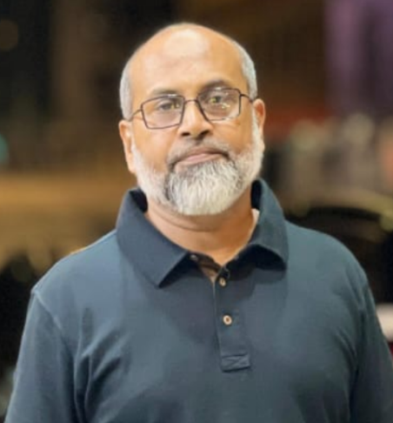






ALAINA Enterprise is dedicated to establishing itself as a leading brand in Bangladesh, specializing in elevator and generator solutions for residential and multistoried buildings. We have assembled a team of the most talented and experienced professionals from both local and international markets to ensure top-tier service delivery.
Our mission is to provide effective, safe, and cost-efficient solutions tailored to our clients' needs. We prioritize customer safety and satisfaction, always placing a high value on client feedback and preferences.
To meet our clients’ expectations, we have partnered with renowned, reliable brands known for their durability, safety, and affordability.
Our commitment to excellence is supported by a highly efficient customer service team, ready to provide 24/7 support. At Alaina Enterprise, your trust is our top priority, and we strive every day to earn and keep it.

All the Best.

Moinul Haque
Chief Executive Officer (CEO)

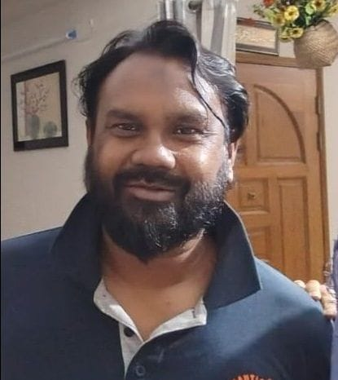

Md. Lokeman
Managing Director
Professional Summary
With over 23 years of experience in the ICT, telecommunications, heavy industry, and construction sectors, I have consistently delivered high-impact projects ranging from a few thousand USD to several hundred million USD. Throughout my career, I have served as a core team member, project manager, and project director, specializing in telecom services, ICT equipment, and end-to-end ICT solutions across both private and public markets.
Core Competencies

- Project Leadership & Management: Proven track record in leading multidisciplinary teams through the full project lifecycle, from initiation and design to implementation and commissioning.
- Telecommunications & ICT: Expertise in datacenter design, power and infrastructure planning, datacom systems, and optical transmission networks.
- Technical Direction & Consulting: Provided strategic technical guidance to government and enterprise clients, including part-time consultancy for China’s TIWTE.
- Global Experience: Successfully executed projects in Bangladesh, China, Malaysia, Singapore, Philippines, Nepal, and Bhutan.
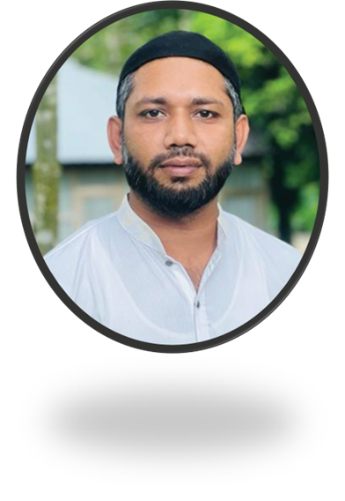






Sales Director at Alaina Enterprise with over 10 years of experience in passenger elevator sales and supply chain management. Proven expertise in managing end-to-end sales processes, client relationship management, and operational logistics. Additionally, I have experience in river erosion control and dam-making activities, contributing to infrastructure resilience and environmental protection—a strategic thinker with a strong track record in business development and cross-functional team leadership.

Md. Morshed
Director Sales

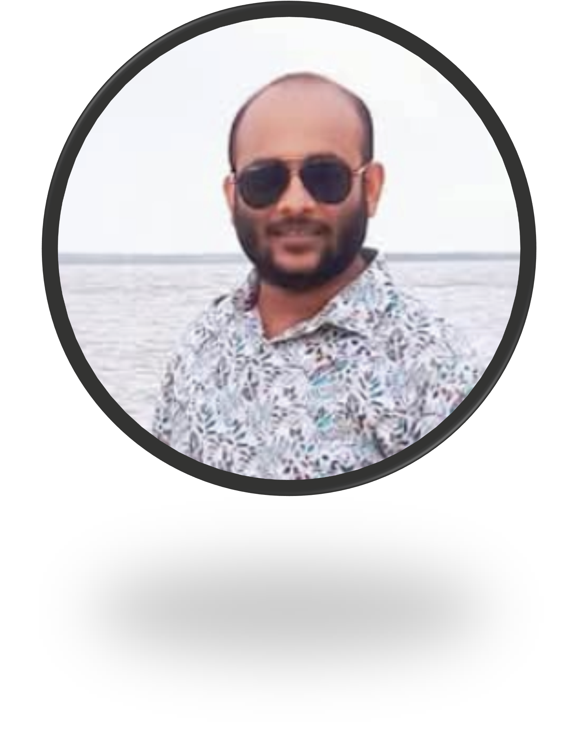

Md. Mohin
Director Marketing

+8801712965112, 01817291846, 01715647935
info@alianaenterprise.com mdlokeman@alainaenterprise.com https://alainaenterprise.com
House# 508 (2ndFloor), Road-7, Avenue -7, Mirpur DOSH,
Dhaka-1216, Bangladesh

Results-oriented Sales and Marketing Manager with over 5 years of experience in the elevator industry, specializing in driving revenue growth and enhancing brand visibility. Proven track record in developing and executing effective marketing campaigns, leading high-performing sales teams, and consistently achieving or exceeding sales targets. Skilled in launching new products and innovative ideas, contributing to the overall success and growth of the organization.

